ENPM 808M: Introduction to Robot Modeling

Exam #1—November 4, 2015

Take home—open book

WSL

1. (20 points) Prove that the following homogeneous transformations cannot be correct.

1.  , b. 

2. (20 Points) Given the manipulator shown in Figure 1.

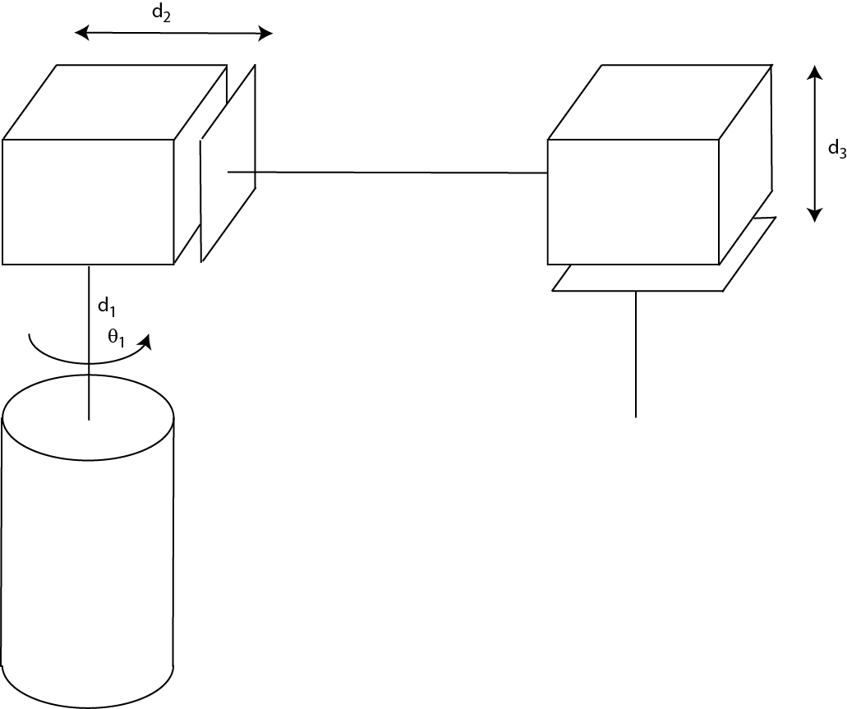

Figure 1: Manipulator

1. Write the homogeneous transformations mapping the world frame into each of the joints origins. Note that the second and third joints coincide and the end effector is at the end of the third joint.
2. Write the Jacobian at the end effector.
3. Given that , , Find values for  such that the reachable work area for the manipulator is a 15 by 15 by 15 cube.

Problem 3 (20 points) Given the parts for the inverted pendulum experiment as shown in figure 2. The parts are to be connected to form an approximation to the inverted pendulum experiment as shown in figure 3.

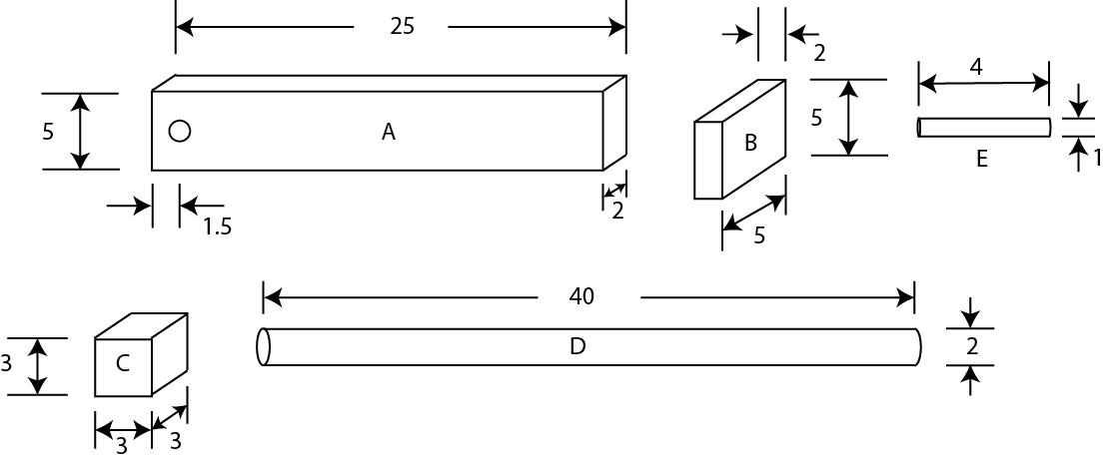

Figure 2: Parts for the inverted pendulum experiment

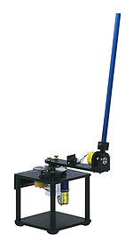

Figure 3: The inverted pendulum

Note: All the dimensions are in centimeters. Part A is the horizontal piece that is rotated by the motor. A torque is applied at the center of the small circle at the left of part A. Part B is attached to the other end (from the motor). Its bottom is flush with the bottom of part A, as can be seen from the picture of the inverted pendulum experiment in Lecture #8. The pendulum is part D. It is connected to the bottom of the cube that is part C. The shaft E goes from the center of mass (CM) of part B to the CM of part C. All of the other connections are at the ends of the parts.

**Notes**:

1. The shape of parts A, B, and C has been simplified.

2. The density of the parts is 2.7 grams per cubic centimeter. There is no damper or spring anywhere in the system.

3. Gravity is present.

Create a SimMechanics model of the simplified inverted pendulum device. You should omit the base that holds the motor and simply apply a torque at the center of the small circle at the left of part A. The torque should be a sinusoid of amplitude .01 Newton meters and frequency 1 radian/second. Run the simulation for 10 seconds. Plot the angle of the pendulum on a scope.

Please submit a copy of your SimMechanics block diagram and the plot of the signal observed on the scope. You can just print them and scan them into the computer if you wish but there is a better way using MATLAB.

Problem 4 (20 points) Given that a manipulator arm has the Jacobian



The link lengths are 

1. You need to do some precise manipulation using this device. You can choose the nominal joint angles at which you do this manipulation. Which of the following choices for the nominal joint angles would be best (1) , (2) ,

(3) ?

1. What joint torques would be required to produce end effector generalized forces (forces or torques) when the joint angles are ?

Problem 5 (20 points) Given the mechanical network pictured in Figure 4. The  are masses. The  are the spring constants of linear springs and the  are the damping coefficients of linear viscous dampers. There is an applied force, denoted by . The displacements of the masses from a given fixed reference are denoted by .

1. Write the three differential equations that describe the motion of this network.
2. Create a Simulink model of this system with the parameter values in Table 1. The signal  and the amplitude is in Newtons. Run the simulation for 10 seconds and plot  as a function of time on the scope. Submit the scope signal as your answer but also submit your Simscape diagram (code). You can just print them and scan them into the computer if you wish but there is a better way using MATLAB.

|  |  |  |  |
| --- | --- | --- | --- |
|  | 1 | 2 | 3 |
| m | 1 kg | 1 kg | 1 kg |
| k | 10 N/m | 100 N/m | 100 N/m |
| B | .1 N/(m/s) | 10 N/(m/s) | 10 N/(m/s) |

**Table 1: Parameter values for the network**

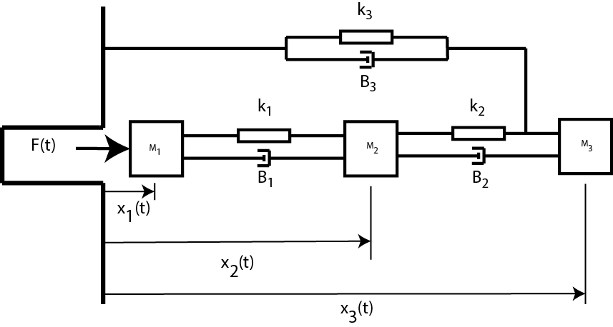

Figure 4: Mechanical network